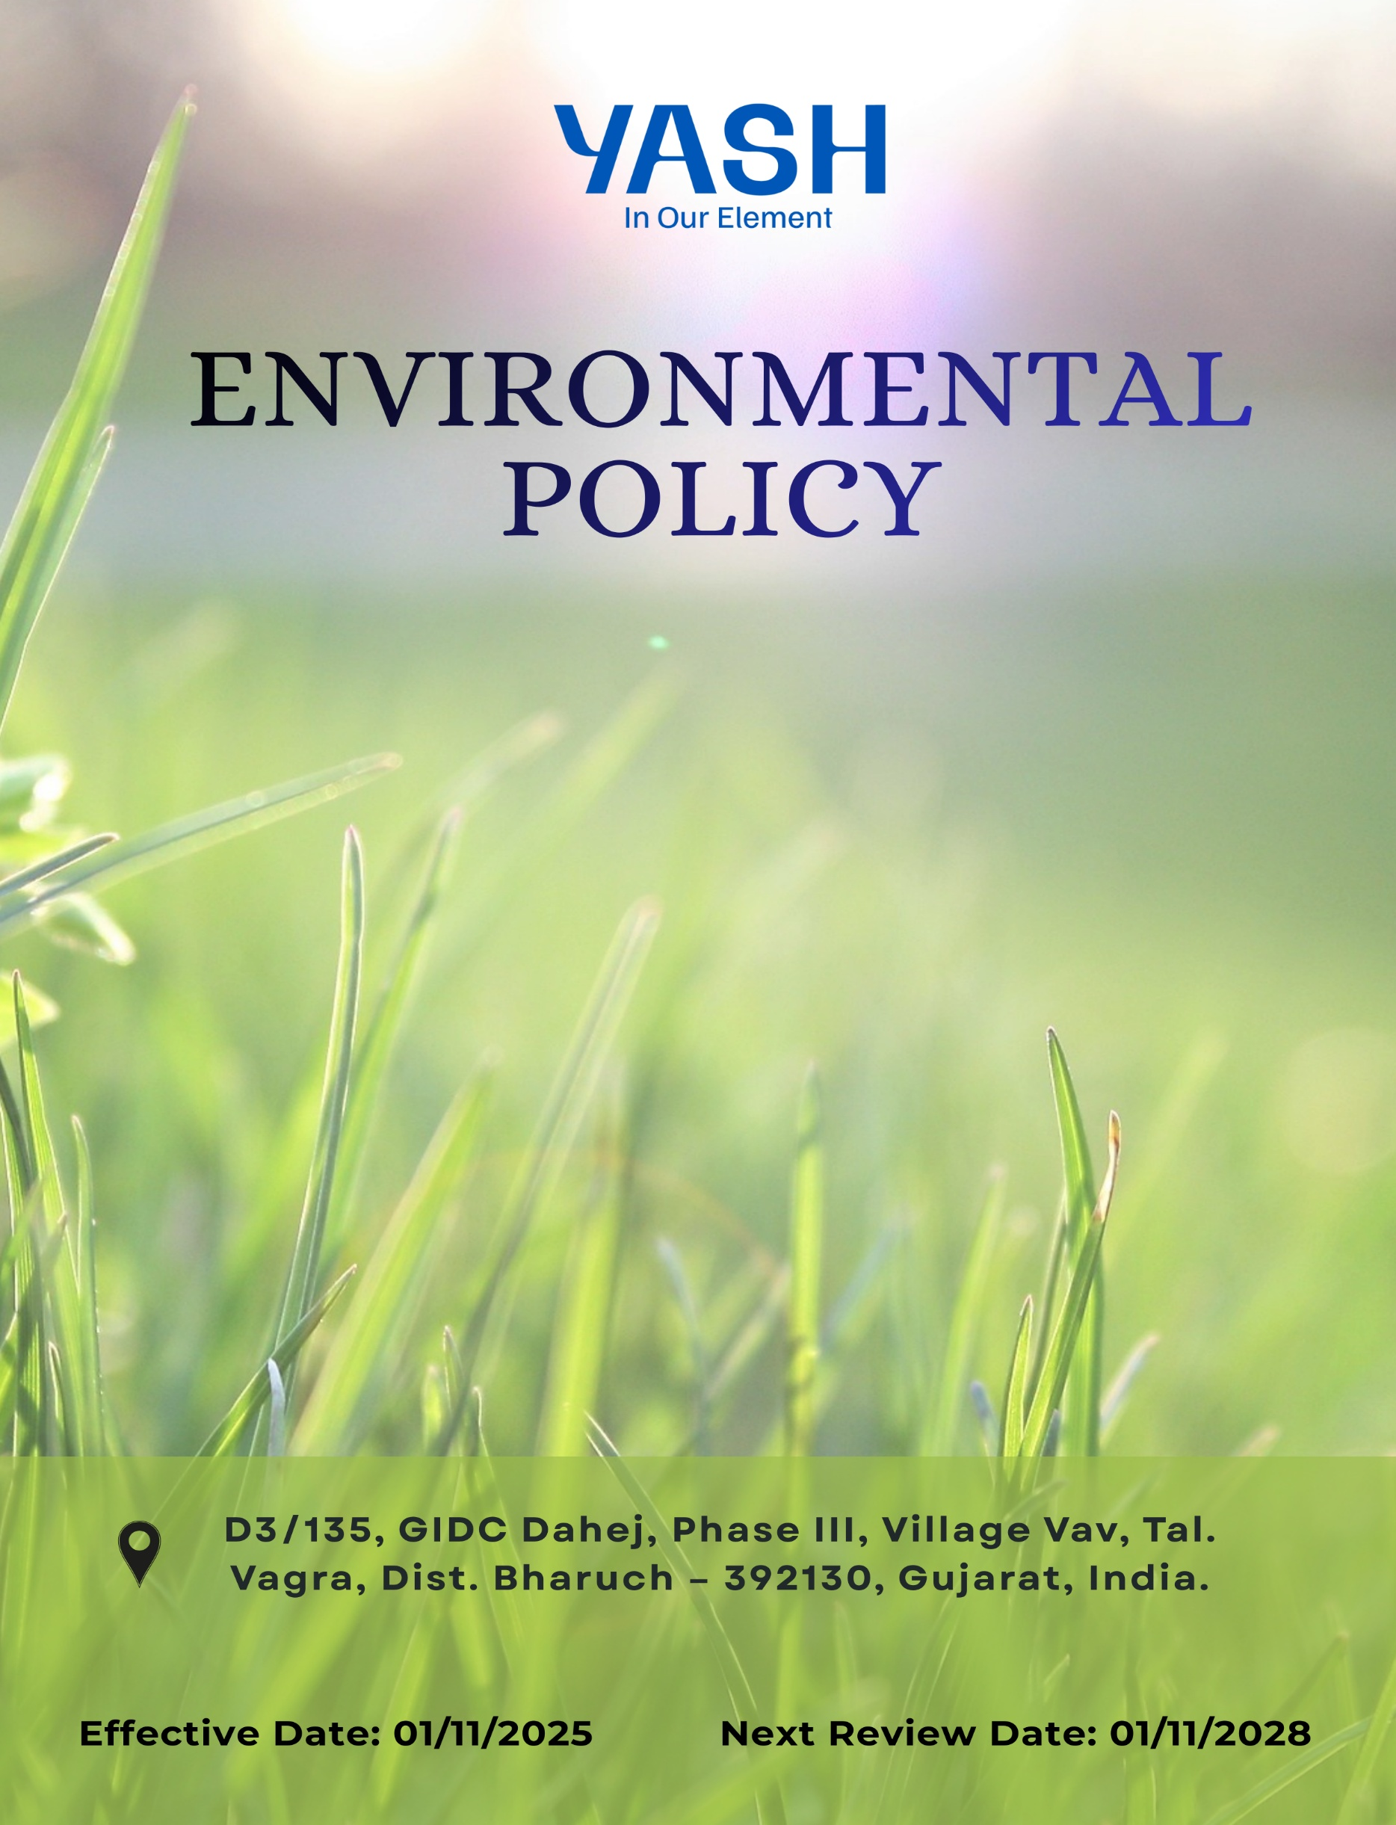

Environmental Policy
Document No. YASH-ENV-001

Revision History:
Revision No. | DCN/CC/No. | Effective Date | Reason for revision
00 | -- | 01/02/2025 | First Issue
01 | -- | 01/11/2025 | Quantitative Objective Incorporated

Contents

Preface 3
Policy Declaration 3
Scope 4
Key Focus Areas 4
Qualitative Objectives 5
Quantitative Targets 6
Alignment with the United Nations Sustainable Development Goals (SDGs) 8
Responsibilities 8
Monitoring, Reporting, and Transparency 9
Review Mechanism and Continuous Improvement 9
Employee Acknowledgment Form 9

Preface
Yash Speciality Chemicals LLP is committed to minimizing its environmental impact and supporting sustainable development through responsible environmental management and continual improvement. As a manufacturer of speciality chemicals, the Company recognizes that its operations have environmental aspects and impacts and therefore strives to prevent pollution, conserve natural resources, and comply with all applicable environmental laws and regulatory requirements.
This Environmental Policy establishes the framework for Yash Speciality Chemicals LLP’s environmental objectives and targets, defines governance and accountability mechanisms, and outlines key initiatives to enhance environmental performance across all business operations. The Policy guides employees, contractors, and relevant stakeholders in promoting environmental stewardship and integrating sustainability principles into day-to-day activities.

Policy Declaration
Yash Speciality Chemicals LLP declares its commitment to protecting the environment by preventing pollution, complying with all applicable environmental laws and regulations, and continuously improving its environmental performance. The Company shall responsibly manage resources, control emissions and effluents, minimize waste, and integrate environmental considerations into operational and business decisions, while promoting awareness and accountability among employees and relevant stakeholders.

1.0 Scope
This Environmental Policy applies to all operations of Yash Speciality Chemicals LLP, including chemical manufacturing, storage, utilities, and supporting functions, carried out at its location. It addresses environmental aspects related to resource consumption, emissions, effluents, waste management, and chemical handling, and extends to all employees, contractors, and service providers operating on behalf of Yash Speciality Chemicals LLP.
Site | Address
Yash Speciality Chemicals LLP | D3/135, GIDC Dahej, Phase III, Village Vav, Tal. Vagra, Dist. Bharuch – 392130, Gujarat, India.

Key Focus Areas
  - Energy Consumption & GHGs – Enhance energy efficiency, adopt cleaner technologies, and reduce greenhouse gas emissions across operations.
  - Air Pollution – Maintain high standards of air quality and emissions control, ensuring compliance with all regulatory requirements.
  - Materials & Waste – Optimize raw material and resource use, manage waste responsibly, and maximize in-house recycling.
  - Water – Reduce water consumption, recycle where feasible, and ensure effective wastewater treatment.
  - Biodiversity – Prevent contamination of land and water, and minimize impacts on surrounding ecosystems.
  - Product Use – Innovate with life-cycle thinking to reduce resource use, emissions, and waste during product use.
  - Product End-of-Life – Promote safe disposal, recovery, and recycling of products and packaging to minimize environmental impact.
  - Customer Health & Safety – Ensure all products meet stringent safety standards, pose no risk to users, and support safe handling, use, and disposal.
  - Employee Awareness & Engagement – Continuously educate and train employees on sustainable practices and environmental awareness; engage suppliers and partners in responsible practices.
  - Environmental Services & Advocacy – Promote environmental responsibility through training, partnerships, and engagement with employees, suppliers, and other stakeholders.

Qualitative Objectives
  - Energy consumption and GHGs
    - Install variable frequency drives (VFDs) on motors, pumps and replace conventional lighting with LEDs where feasible.
    - Conduct Bi-annual energy audits and optimize boiler, chiller, and HVAC efficiency to reduce consumption.
    - Utilize waste heat recovery from existing processes to lower energy use and GHG emissions.
  - Air Pollution
    - Maintain the efficiency scrubbers, filters, and ventilation systems in manufacturing and utilities to control emissions.
    - Monitor stack emissions and ambient air quality regularly to ensure compliance with local regulations.
    - Minimize emissions from internal operations and transport through process optimization, proper chemical handling, maintenance, and efficient vehicle usage.
  - Materials & Waste
    - Optimize raw material usage by improving process efficiency and minimizing scrap.
    - Reuse packaging materials within existing in-house systems.
    - Ensure proper segregation, storage, and disposal of hazardous waste via authorized vendors.
  - Water
    - Reduce freshwater consumption through efficient use and process optimization.
    - Maintain and optimize existing water reuse and recycling systems to maximize efficiency.
    - Ensure continued compliance of effluent treatment systems with regulatory standards.
  - Biodiversity
    - Develop green belts around manufacturing site or allocated land/sites with native tree plantations.
    - Collaborate with local environmental organizations to support habitat conservation.
  - Product Use
    - Provide guidance to users on responsible and efficient product use to reduce environmental impact.
    - Collect feedback from customers to improve product sustainability and safe usage.
    - Promote practices that reduce emissions, resource use, and waste during product application.

  - Product End-of-life
    - Enable recycling and recovery of products and packaging wherever possible.
    - Ensure safe disposal of expired or off-spec chemicals through authorized services.
    - Encourage customers to return packaging for reuse or recycling.
    - Track end-of-life product management to improve circular economy practices.
  - Customer Health and Safety
    - Ensure all products comply with global and local safety regulations before release.
    - Maintain and update labeling, hazard communication, and SDS for regulatory compliance.
    - Monitor and review product safety performance to identify improvements in handling and usage.
    - Conduct targeted training for customers on safe handling practices and emergency response.
  - Employee Awareness & Engagement
    - Conduct periodic environmental awareness and compliance training for employees relevant to their roles and operations.
    - Integrate environmental responsibilities into SOPs and daily work practices to reinforce sustainable behavior.
  - Environmental Services & Advocacy
    - Conduct employee training on environmental responsibility and sustainable practices.
    - Engage suppliers in environmentally responsible procurement and operations.
    - Support local environmental initiatives and sustainability programs.

Quantitative Targets
The baseline year for all quantitative environmental targets is established as FY 2022-23, serving as the reference point for measuring progress across Yash Speciality Chemicals key focus areas. This baseline enables systematic evaluation of improvements in resource efficiency, emissions reduction, and overall environmental performance.
  - Energy consumption and GHGs
    - Increase the use of renewable energy to 30% of total energy consumption by FY 2029-30.
    - Reduce total energy consumption by 15% by FY 2029-30.
    - Achieve total reduction of Scope 1 and Scope 2 GHG emissions by 15% till FY 2029-30.

  - Air Pollution
    - Achieve a 30% reduction in air pollutant emissions compared to FY 2022–23 by FY 2029–30 through effective operation and maintenance of scrubbers, filters, and ventilation systems.
    - Maintain 100% compliance with national ambient air quality standards for indoor and outdoor emissions.
    - Reduce diesel vehicle use by 15% by FY 2029-30 through route optimization and improved scheduling.
  - Materials & Waste
    - Recover and reuse 95% of solvents used in batch processes by FY 2029-30.
    - Reduce process waste and material losses by 10% by FY 2029–30 through improved process control and material efficiency.
  - Water
    - Reduce water consumption across operations by 30% by FY 2029-30 through implementation of water-efficient technologies and rainwater harvesting systems.
    - Reduce process water losses (Leakages, overflows, Blowdown) by 80% till FY 2029-30.
  - Biodiversity
    - Plant and maintain 3000 native trees by FY 2029-30 around processing facilities.
    - Implement 2 habitat restoration projects by FY 2029-30 in collaboration with community and environmental partners to prevent contamination and ecological degradation.
  - Product Use
    - Life cycle measurement to be done of 100% key specialty chemical products by FY 2029-30.
    - Ensure 100% of products are supplied with clear usage instructions and environmental handling guidance.
  - Product End-of-life
    - Increase the use of recycled and repurposed materials to 50% in product formulations, intermediates packaging and bulk containers by FY 2029-30 to promote circular resource use.
    - Ensure provision for 100% safe disposal of expired or off-spec products through authorized waste management facilities till FY 2029-30.
  - Customer Health and Safety
    - Conduct 2 customer safety awareness or communication initiative annually for key products.
    - Ensure 100% of products have accurate labeling, hazard communication, and up-to-date Safety Data Sheets (SDS).

  - Employee Awareness & Engagement
    - Achieve 100% employee coverage under environmental, health, and safety training annually.
    - Conduct 3 employee engagement initiatives till FY 2029-30 related to sustainability or environmental performance.
  - Environmental Services & Advocacy
    - Allocate 1% of annual profits toward community and environmental stewardship initiatives by FY 2029-30.
    - Train 80% of key suppliers on sustainability practices and environmental management by FY 2029–30.

Alignment with the United Nations Sustainable Development Goals (SDGs)s
The sustainability objectives and performance targets align with the following Sustainable Development Goals (SDGs):
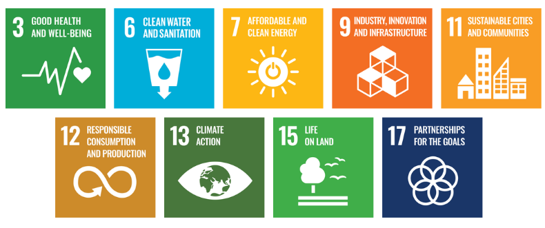

Responsibilities
6.1 EHS Manager: Oversees implementation and monitoring of the Environmental Policy, ensures regulatory compliance, leads training, and coordinates environmental reporting.
  - Department Heads & Operations Teams: Integrate environmental goals into departmental functions, collaborate with the EHS Manager, and implement initiatives such as waste reduction, water conservation, and energy efficiency.
  - Employees: Follow environmental guidelines, participate in sustainability initiatives, and adopt best practices to support Yash Speciality Chemicals’ sustainability objectives.
  - External Stakeholders: Support sustainability efforts through partnerships and compliance with environmental standards.

7.0 Monitoring, Reporting, and Transparency
Yash Speciality Chemicals LLP continuously monitors its environmental performance across key areas, including energy use, greenhouse gas emissions, water management, waste reduction, and product safety. Key Performance Indicators (KPIs) are defined for each area and tracked through internal systems to measure progress against sustainability targets. Performance is reviewed quarterly, with findings consolidated for senior management to guide strategic decisions. Annual assessments evaluate achievements, identify gaps, and recommend corrective actions, while relevant outcomes are communicated to stakeholders to ensure transparency and accountability. All monitoring and reporting are conducted in line with regulatory requirements and industry best practices to maintain accuracy and credibility.

8.0 Review Mechanism and Continuous Improvement
This policy will be reviewed once in every three years, or earlier if required by the EHS Manager and updated as necessary to reflect changes in regulatory requirements, industry best practices, and internal environmental goals. Updates will be communicated to all stakeholders to ensure consistent application and engagements. Necessary revisions will be made to strengthen environmental commitments and drive continuous improvement. Any significant changes or updates will be communicated to all employees and relevant stakeholders to ensure effective implementation.

Prepared By: Reviewed By: Approved By:

Vishal Prajapati Prakash Patel Pritesh Patel
EHS, Manager QS, Head Site Head

Employee Acknowledgment Form
I hereby acknowledge that I have read and understood the Environmental Policy of Yash Speciality Chemicals LLP. I am aware of the company’s commitment to responsible environmental practices, including energy efficiency, resource conservation, waste reduction, pollution control, and strict compliance with all applicable environmental laws and standards. I understand that environmental sustainability is a collective responsibility, and I pledge to follow sustainable practices in my daily work, minimizing waste, using resources efficiently, and adhering to the company's environmental protocols. I will actively support Yash Speciality’s efforts to achieve its sustainability goals and contribute to creating a cleaner, safer, and more responsible workplace.
By signing this document, I confirm my commitment to the environmental values of Yash Speciality Chemicals LLP and agree to participate in training sessions, awareness programs, and continuous improvement initiatives as required.

Employee Name | : _________________________
Employee ID | : _________________________
Department | : _________________________
Signature | : _________________________

